Sequence Puzzle

Concept

This is a simple puzzle game in which users move the piece of numbers to order by ASC. ( 1, 2, 3, 4, 5, 6, 7, 8)
Users can move one number each time into the blank space and if steps > 100, the game is over.

UI

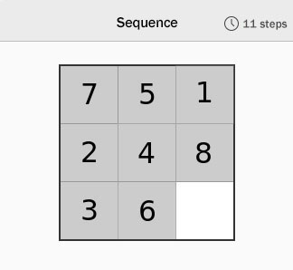

If the user opens the game, the above screen should be displayed. At that time, the initial steps should be zero.
If users win, the congratulation dialog will be displayed. Otherwise, “Game Over”

Requirements

- Please use Bootstrap Grid for layout
- Please use Bootstrap5 buttons
- Deadline is 2 days.

Bonus

- Plus if mobile responsive
- Plus if any animation
- Big plus if you use Class during the development
- Huge plus if you implement the random arrangement logic whenever the game is started.

Version 1.1
- Please add timer in the top-left corner.
- Once game is finished, please save the steps and current time (e.g: 120s) into local Storage.
Here, we need only top score. It means you don’t need to update the score and current time if they are less than one already saved.
- Please add keyboard event (if you already implemented that, please add mouse event. It’s Ok if you already done both of them.)

Version 2.0 (AI)
Well, Its AI generation now. Let us challenge a simple AI task together!

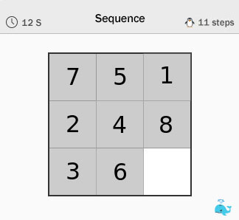

- Click the fish icon on the bottom-right corner to get AI assistant.
How will AI work in our game? Simple!
Let’s assume that there is the score for each status in the game. We can simply calculate the score by using manhattan algorithm.

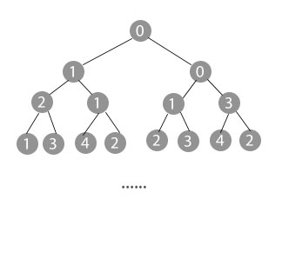
The whole process in which we solve a puzzle is like as search in tree structure.
The top node represents the first status. As steps go, the count of nodes are rapidly increased.
At the specific deep, we can select the best node (top score) and path.
Once the path is confirmed, we can move numbers on the screen.

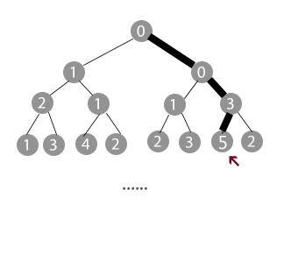

At the moment, please use 10 as deep.
- When we click the fish icon, the search will be processed. In meanwhile, Please lock screen and show waiting animation…
Once the calculation is finished, the screen will be updated step by step for 10 times.

